How to add a new wireless alarm system (ASK/OOK signal transmitting) into the alarm fingerprinting code
Adding a new alarm system into the fingerprinting code consists of 2 Phases:
Phase 1 = Test Phase, establish signal parameters for processing.
Phase 2 = Add tested code into the alarm fingerprinting code modules.

Note: Replace /user in any scripts, with your home directory.

Phase 1 - Test phase
Create a folder called "Alarm name" GnuRadioFiles.

Within TestAlarmGnuRadioFiles folder, create a folder called Gnuradio Flowgraphs.
You will be creating 2 flowgraphs - the capture and processing flowgraphs for testing (and then later edit and save the processing flowgraph for use in the processing code).

Create a folder called Audacity projects
You will be opening some of the output graphs in audacity, to "tune" the GnuRadio processing flowgraph. You will also be comparing peripheral signal content and may want to save some of these projects for future reference.

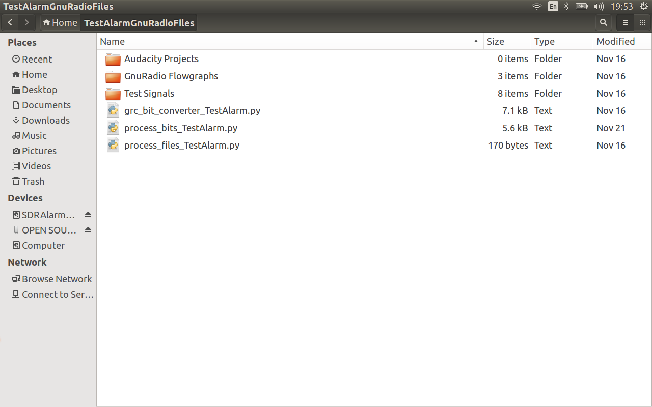

Create a folder called Test signals.
This will be used to Capture test signals from the alarm, such as Reed, PIR and Keyfob signals
Create folders for each alarm peripheral being tested, e.g. TestAlarm Reed 1.
These will be used to file the original and converted to hex signals (tidy)

Important : If you have multiple peripherals of the same type, make a note of which Reed 1 is, and which is Reed 2 - either write this in marker pen on the Reeds, or note down the serial numbers (if there are any noted).

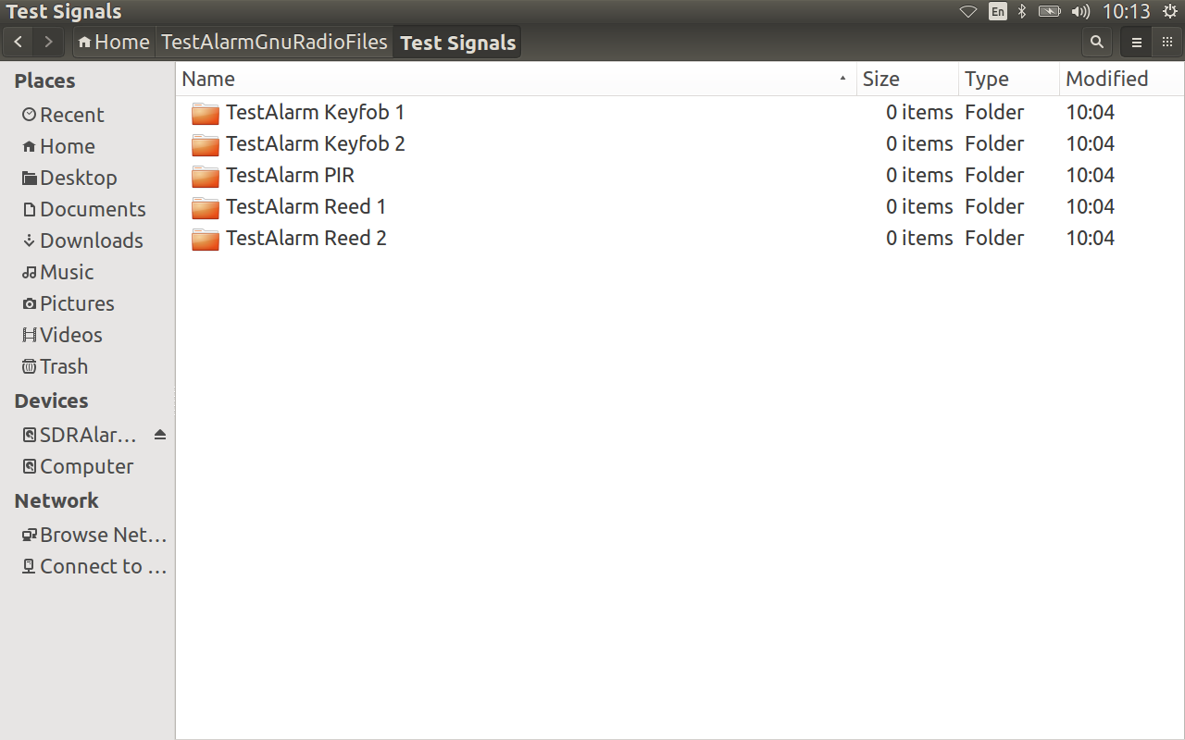

Copy the 2 flowgraphs (the Capture and 4 File Output flowgraphs) from one of the alarm systems you have already completed, into the /TestAlarm/GnuRadio Flowgraphs folder.
You will use these, as a base, to create customized versions for your TestAlarm system.

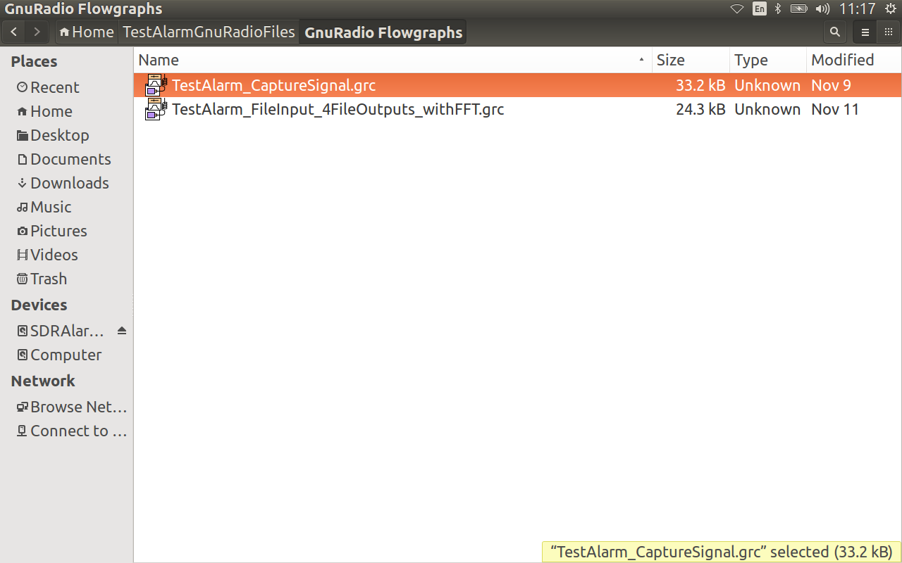

Side Note: For all of the next activities, it was useful to enable workspaces in Ubuntu (System settings - Appearance - Behaviour).
Clockwise, starting top left:
Workspace 1 - Control+Alt+T terminal for running .py files
Workspace 2 - $ gnuradio-companion (Gnuradio software)
Workspace 3 - $ audacity (Visually inspect signal files during initial setup phase - tweaking processing variables and visually inspect during reversing phase)
Workspace 4 - code text files

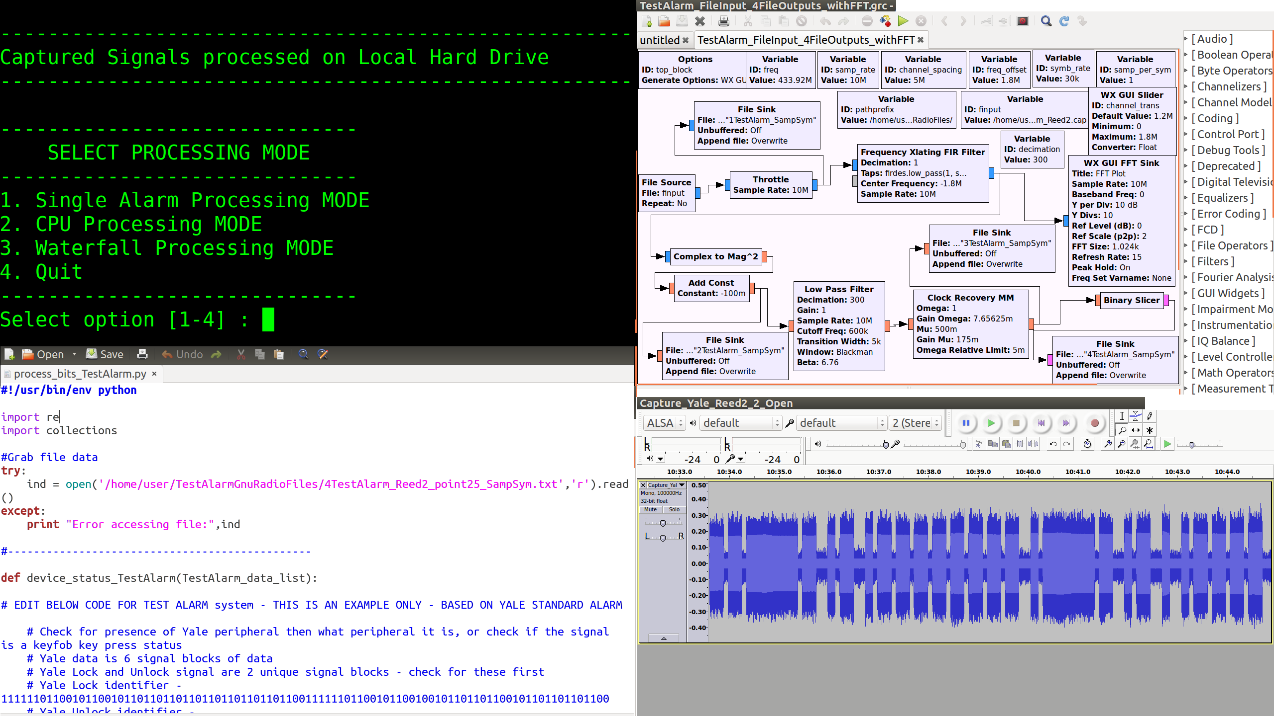

Copy the test code into the "Alarm name" GnuRadioFiles folder:
- process_files _TestAlarm.py

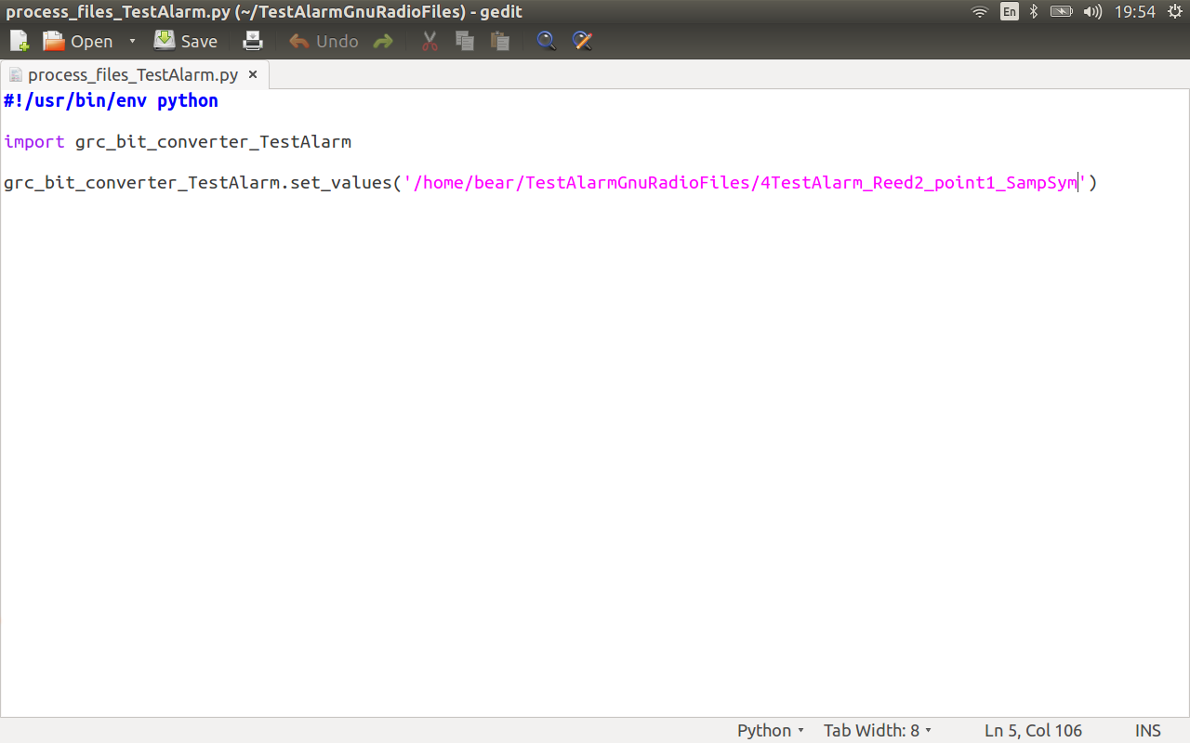

- process_bits_TestAlarm.py (use this to count the frequency of the bit sequence occurrences, for processing into the actual symbol data, also write the alarm peripheral identifier code - which, when working, will be added to alarm_fingerprint.py)

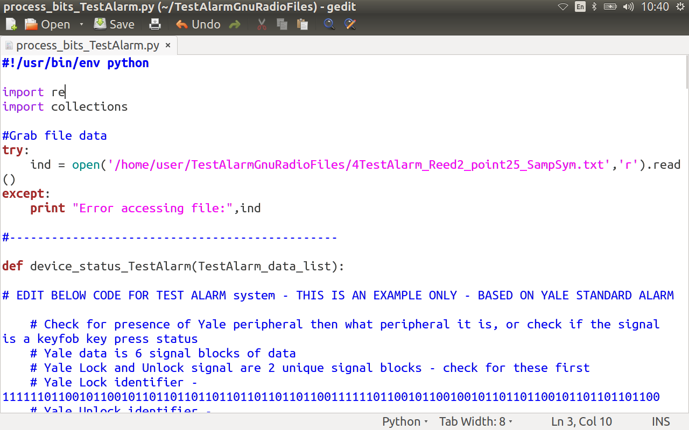

- grc_bit_converter_TestAlarm.py (Don Weber's grc_bit_converter.py file https://github.com/cutaway/grc_bit_converter edited to output hex values)

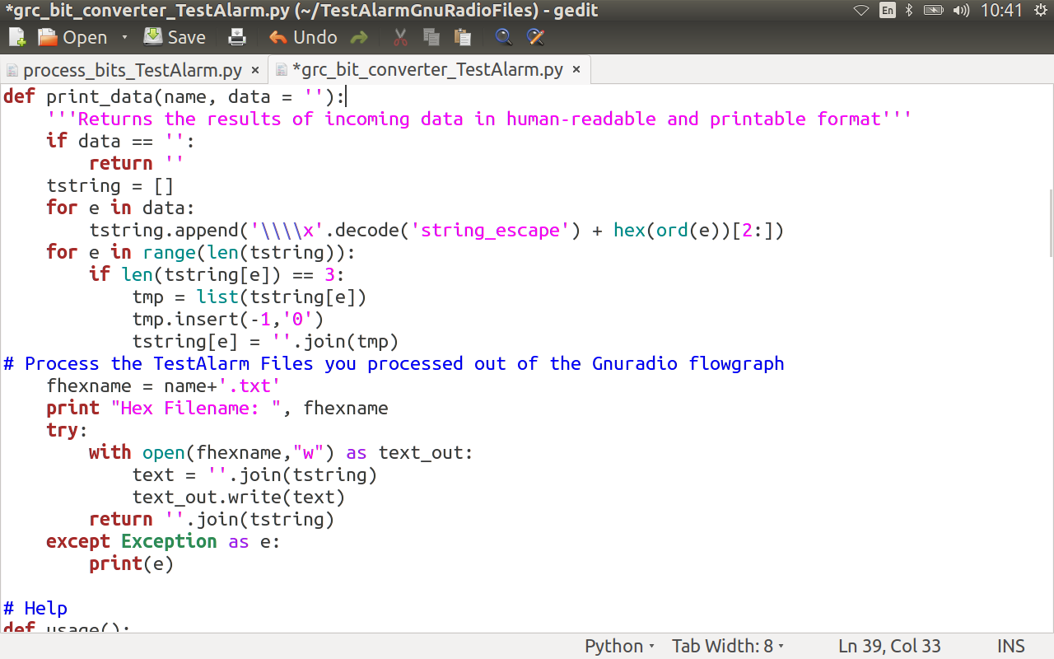

GnuRadio Capture Flowgraph
Run the TestAlarm_Capture.grc flowgraph.

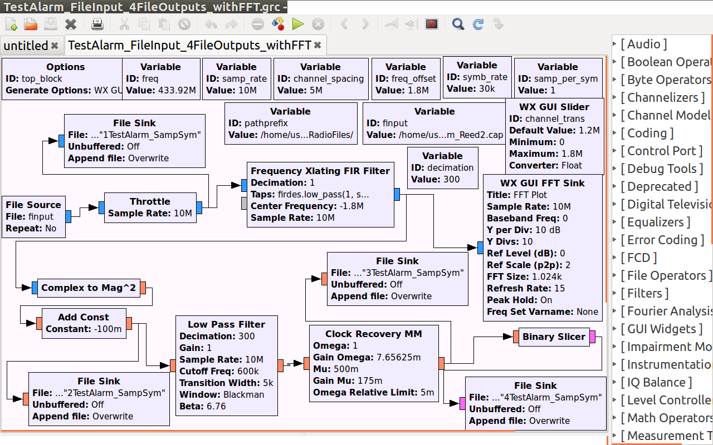

Press a button on a Keyfob, or, open or close a Reed, or, trigger the PIR by walking in front of it.
Experiment with setting the frequency offset, so you can avoid the HackRF DC spike. Observe the signal transmitting in relation to the DC spike, in the FFT graph, and settle on a frequency offset that produces good quality .cap capture files.

Bosch PIR Open FFT
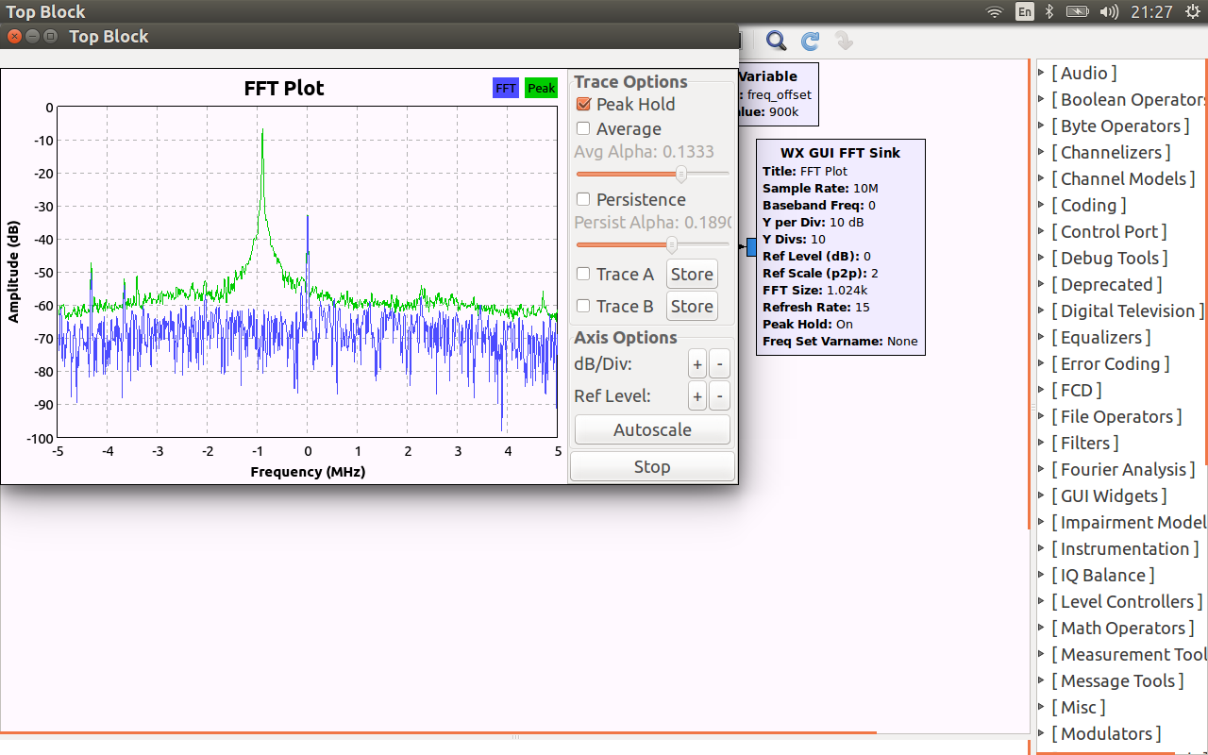

Produces a signal capture file, e.g. Capture_TestAlarm_Reed2.cap file.
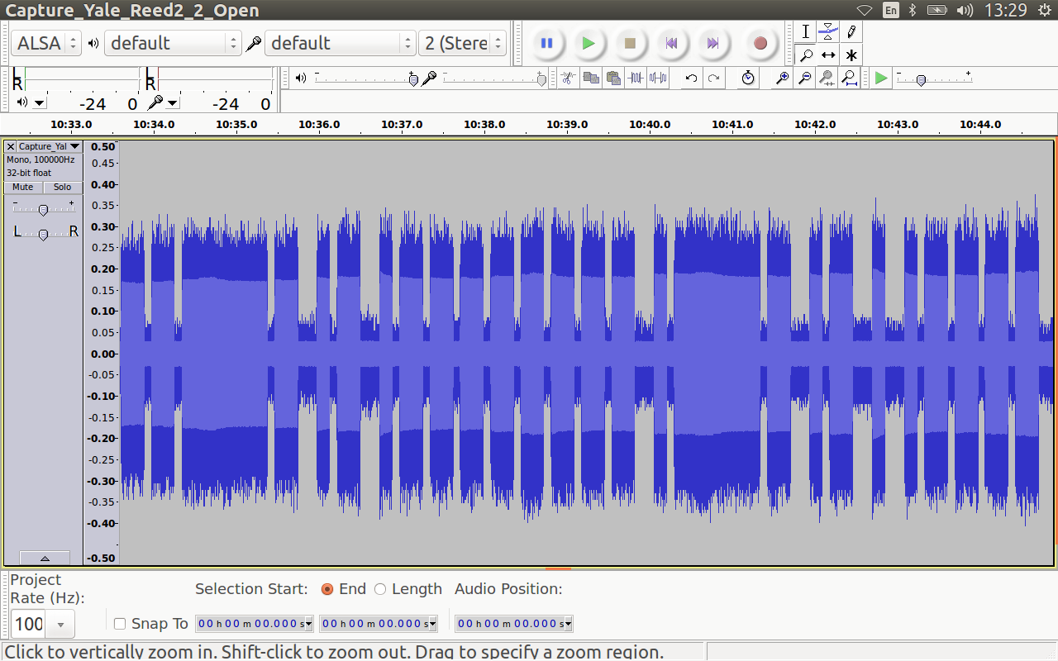

This .cap file is then used as input for the next (processing) Gnuradio flowgraph. To decimate and clean up the signal, so the actual signal binary and hex values are able to be extracted more easily.

GnuRadio Processing Flowgraph Experimentation
The aim of the GnuRadio processing graph, is to take the captured signal file which has millions of sample points, and "clean and reduce" it into a signal that can be more easily processed further.

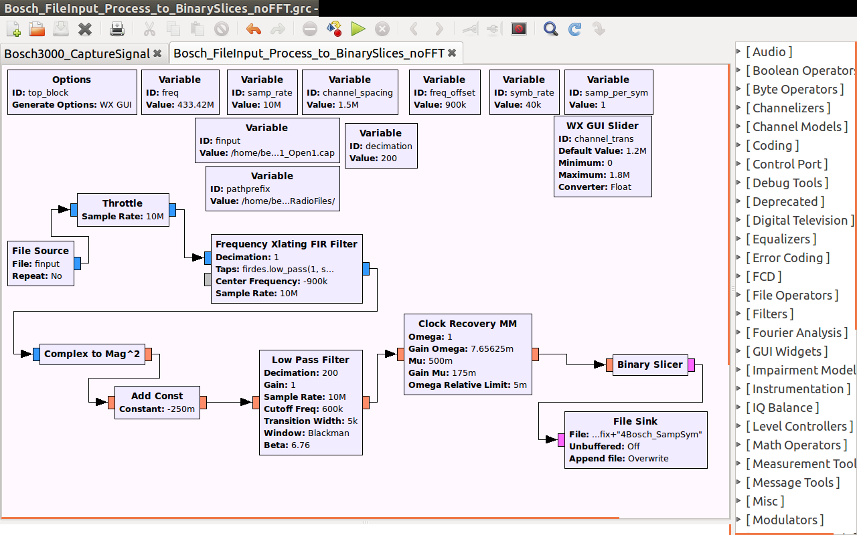

At each step, whilst experimenting with the gnuradio flowgraph variables, it is useful to look at the output signal, in order to gage what changes are producing a better quality signal output (square or triangle wave output).
The most useful signal output graphs to look at, are:

- the FFT whilst the signal transmits, (you can verify visually that the capture file signal has transmitted and processed).

File produced: 1TestAlarm_SampSym (original file after throttle applied)
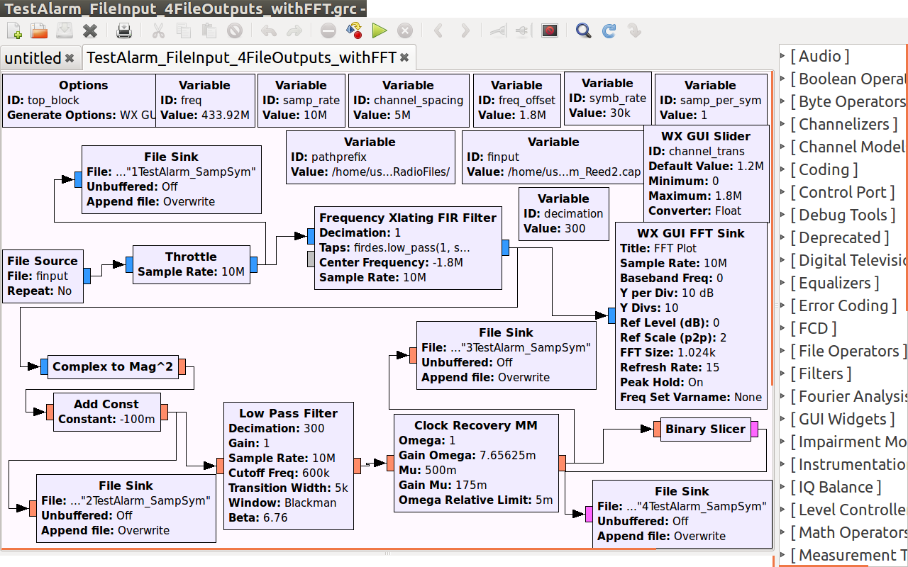

- after processing is completed, look at the signal output from the Add Const Constant Block (which is used to offset the signal downwards - easy noise floor elimination).
File produced: 2TestAlarm_SampSym (filtered file after add const block - offset applied)

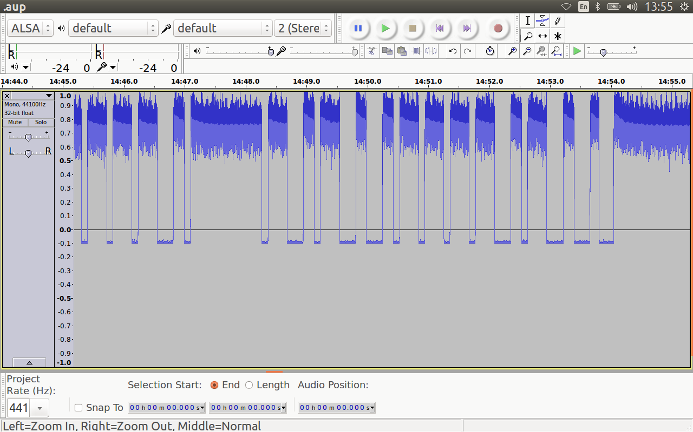

- look at the signal output from the Clock Recovery MM Block :
To assess the signal quality, open this file output from the Clock Recovery Block – the Signal should be well defined, and give a consistent/good indication of the symbols found within the signal).

File produced: 3TestAlarm_SampSym
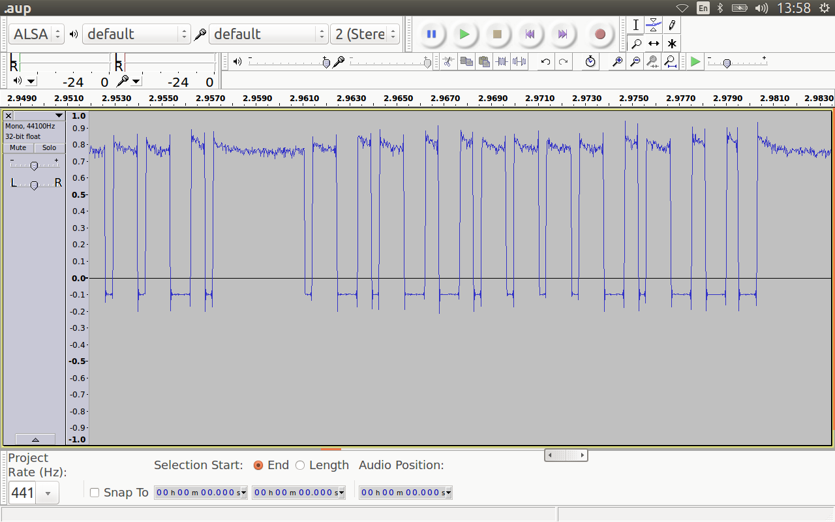

- the Omega value is based on the sym_rate, which can be calculated from the Add Const Constant Block symbol timings in audacity,
- the decimation, which is found by changing the variable and observing the resulting output.

- 4TestAlarm_SampSym (binary sliced signal - this is the file that is processed further)
Binary sliced signal - this 4TestAlarm_SampSym file to be processed further to fingerprint the alarm system.
Note: This 4TestAlarm_SampSym file and the original .cap file are the only files you need to keep, for the alarm identification.

NOTE: The following, manual process steps, are only necessary during this Testing phase, where the variables and offset value range for the alarm system needs to be determined. All the manual processing will be automated, in the add to alarm fingerprinting code Phase.

Once you are sure the variables for processing give you a sufficiently good quality output signal, keep the 4TestAlarm_SampSym output file and rename it, to reflect what the signal contains and what offset you used:
4TestAlarm_Reed2_point1_SampSym

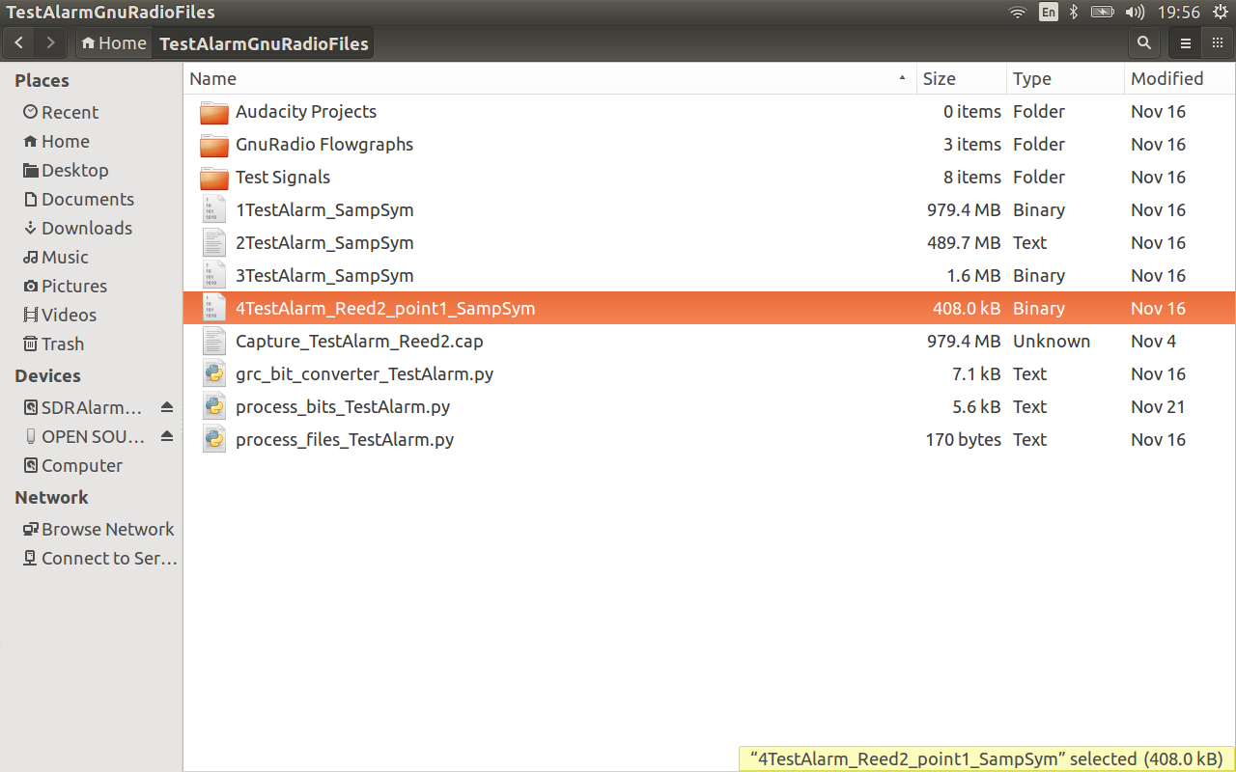

Open process_files_to_alarmlog_TestAlarm.py and copy the 4TestAlarm_Reed2_point1_SampSym filename in.

Switch to the terminal and run process_files_to_alarmlog_TestAlarm.py
This code uses Don Weber's grc_bit_converter.py file
A text file is produced (4TestAlarm_Reed2_point1_SampSym.txt), containing hex values in \xff format.

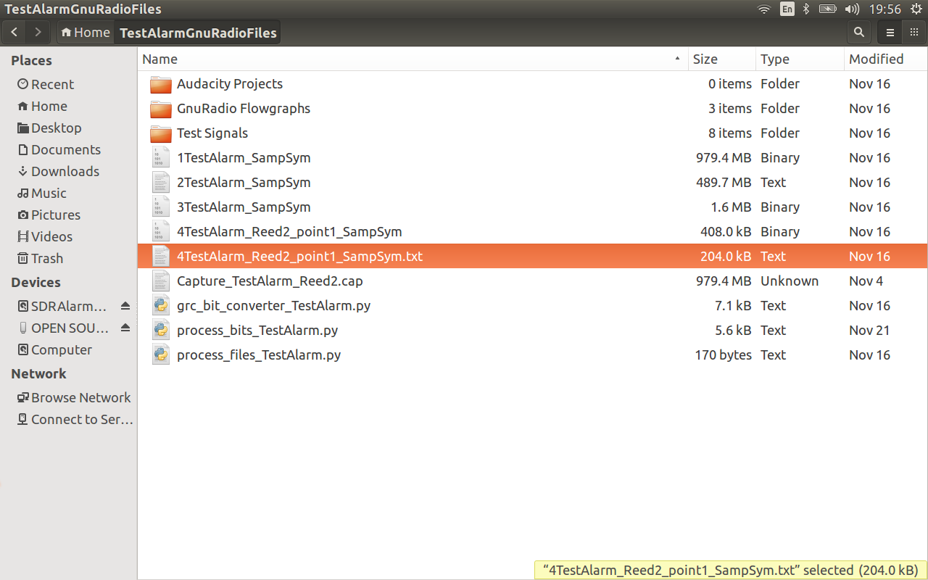

Open the text file, if you only triggered one alarm peripheral, delete extraneous leading \x00 and trailing \x00. (Edit down the signal to actual content, leaving at least 9 \x00 leading and trailing. This will cut down on processing time)



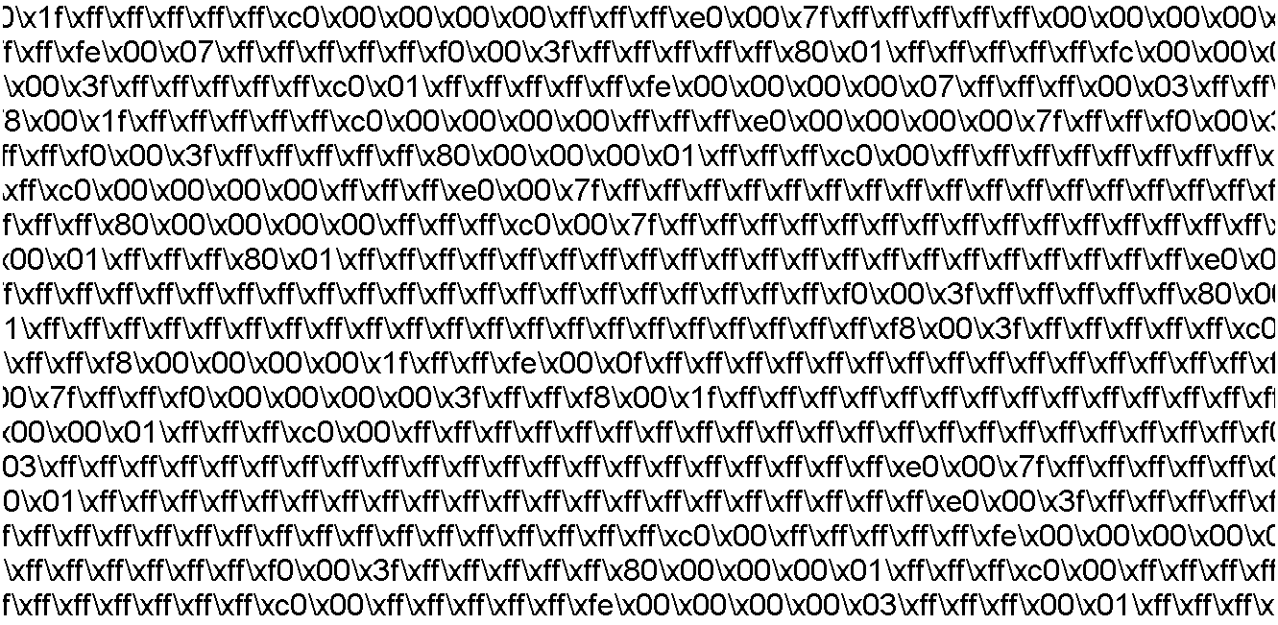

Open process_bits_TestAlarm.py and copy the 4TestAlarm_Reed2_point1_SampSym.txt filename in.
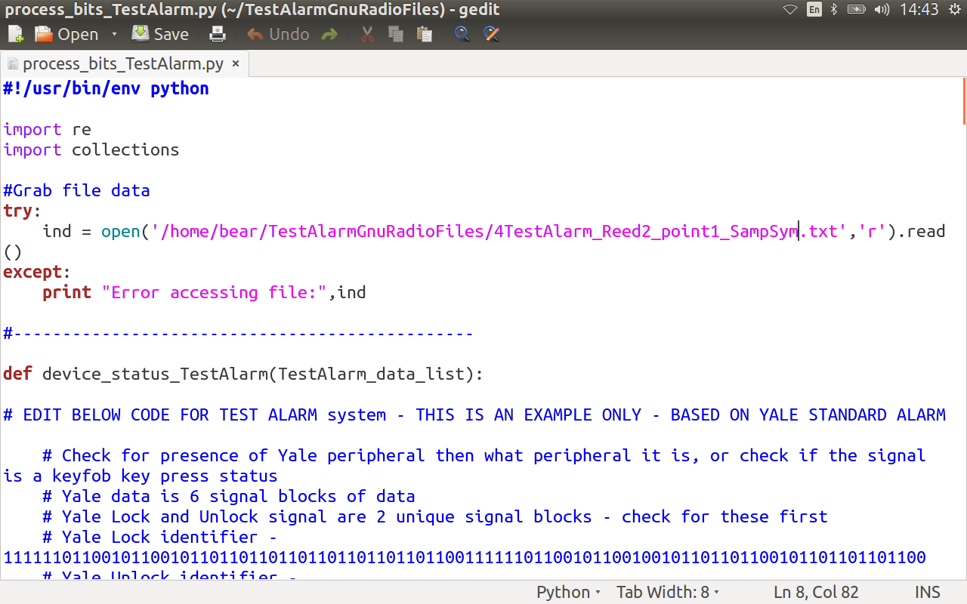

Enable and disable parts of the process_bits_TestAlarm.py code.
There are sections for counting the frequency of 00000 and fffff or 1111 sequences. The processing is dependent on what the signal hex results are, so this is where decisions have to be made on processing the raw hex, or convert to bits and work with raw bits.
It is different for each alarm system. The example code for the Yale alarm system has been left in process_bits_TestAlarm.py, as an example of what was done.
Use process_bits_TestAlarm.py as a code scratch pad, to ID the alarm peripheral signal.

Run process_bits_TestAlarm.py
Result of the file:
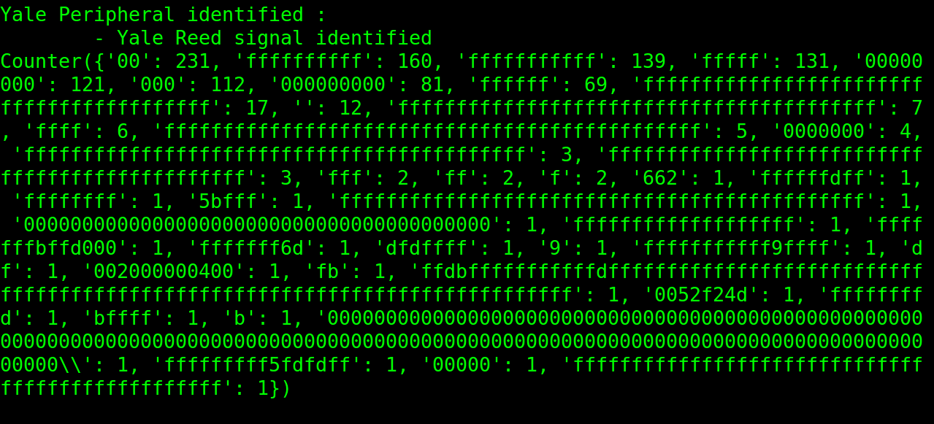

Delete 1TestAlarm_SampSym and 2TestAlarm_SampSym files.
Move 3TestAlarm_SampSym , 4TestAlarm_Reed2_point1_SampSym , 4TestAlarm_Reed2_point1_SampSym.txt and Capture_TestAlarm_Reed2.cap files into the Test signals\TestAlarm Reed 2 folder, for future reference/cross checking experiment results.

End of testing phase

Phase 2 - Adding alarm into the fingerprinting code

The following is a detailed example of adding the Bosch 3000 alarm system into the alarm fingerprinting code:

Using Test signal variables above, processed and compared several signals for each peripheral. Compared inter peripheral signals, and intra signal peripheral signal parts, to determine patterns (preamble and synch word defined and same for each Bosch peripheral ? status bits ? peripheral identifier ? serial number bits ? CRC ? ...)

Bosch Reed Open signal consists of 8 parts. Offset -0.25.
Part 1 of 8, after Throttle in GnuRadio flowgraph, zoomed in shown:
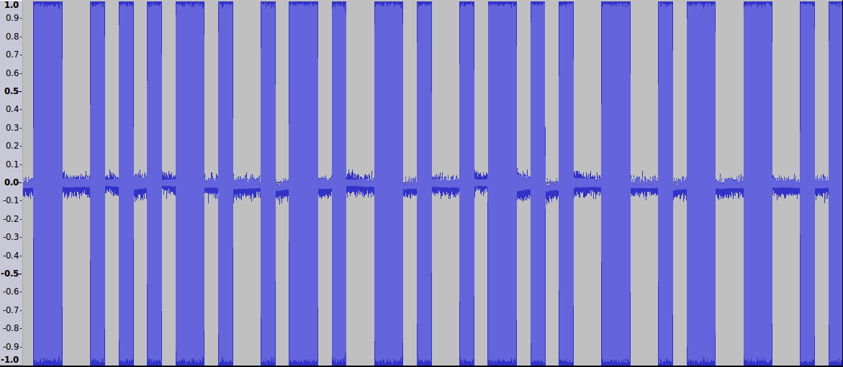

Bosch Reed Open signal consists of 8 parts. Offset -0.25.
Part 1 of 8, after Add Const Block in GnuRadio flowgraph, zoomed in shown:
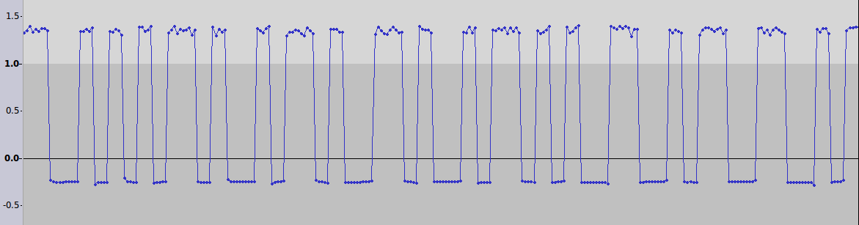

Bosch Reed Open signal consists of 8 parts. Offset -0.25.
Part 1 of 8, after Clock Recovery Block in GnuRadio flowgraph, zoomed in shown:
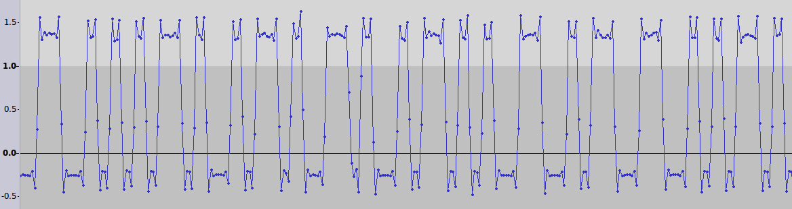

From looking at the Bosch Reed 1 hex output, each signal part is short and well defined (large segment of 00s between the signal parts).
- Decision 1: Easy to extract signal packet parts.
- Decision 2: Process raw hex.

Put the .txt file into process_bits_Bosch.py and use Counter function to count the frequency of the hex values.
This will be used to then decide what range of f or 0's, to use to process and convert the hex into the actual signal symbol content.

Bosch Keyfob 2 Unlock signal
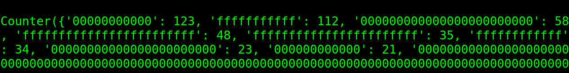

Keyfobs are 4 part signals
Bosch KF1 Dot1_1. Offset -0.05. Full signal height ~0.18
count:0 count:f
86:11 95:11
82:24 84:24
1:23 1:23

Bosch KF1 Dot1_3. Offset -0.05.
count:0 count:f
88:11 84:11
82:24 84:24
48:12 54:12
3:23 3:23

Other results can be found in Appendix A.

Find patterns
Find the common patterns within each Bosch peripheral signal, and between each Bosch peripheral signal.
Line the signal parts up in audacity and compare what is the same, and what is different.

Import Bosch Keyfob signal into audacity.
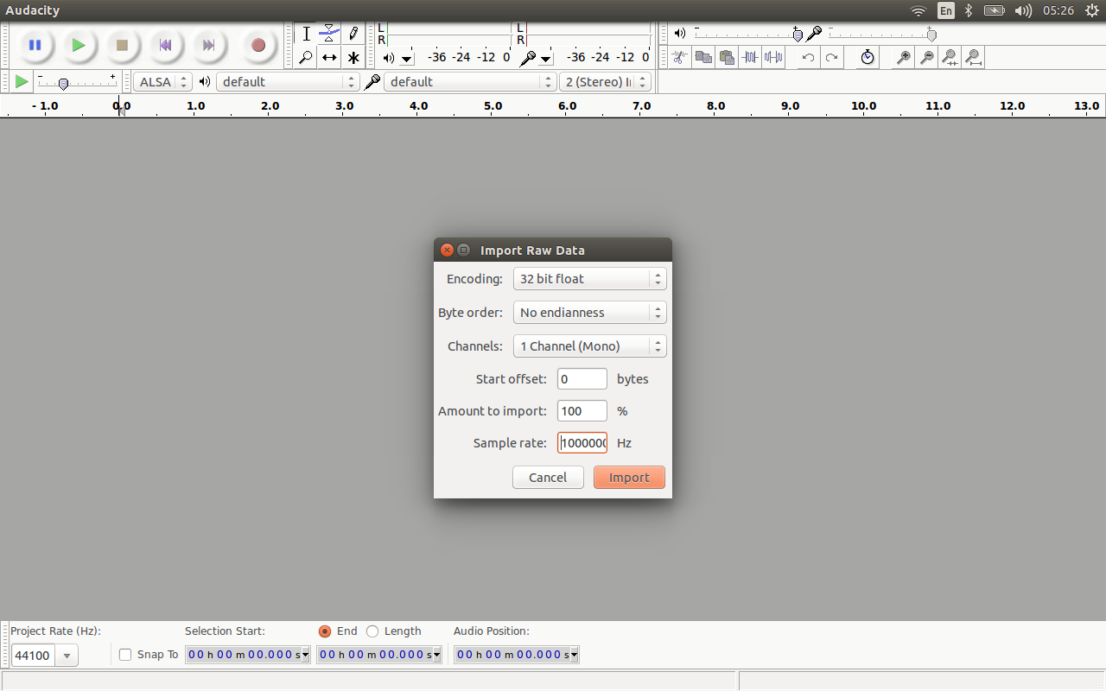

Bosch Keyfob button signals consist of 4 parts. Offset -0.25, Part 1 of 4 shown.
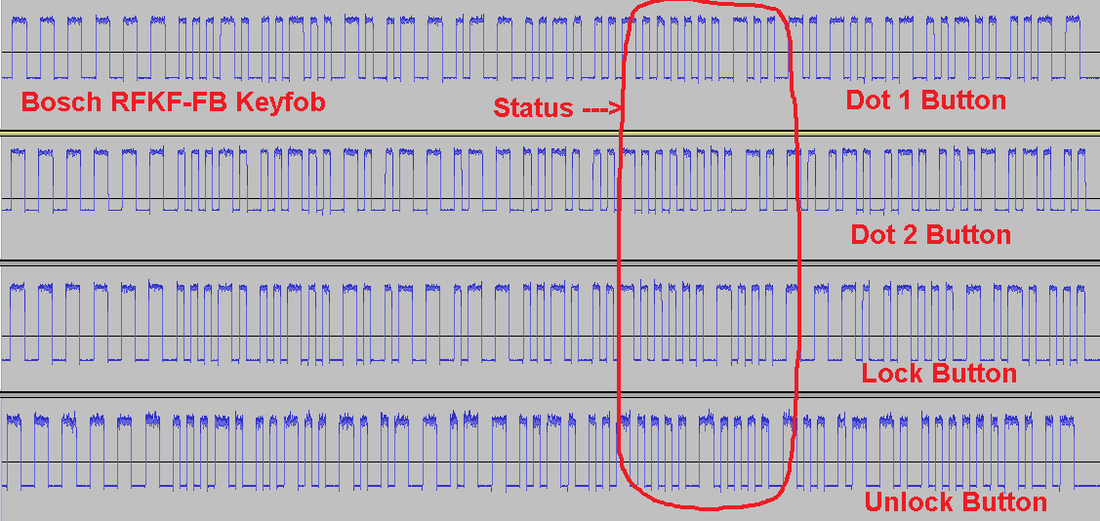

Zoomed in – Level 1 Bosch KeyFob Unlock Symbols
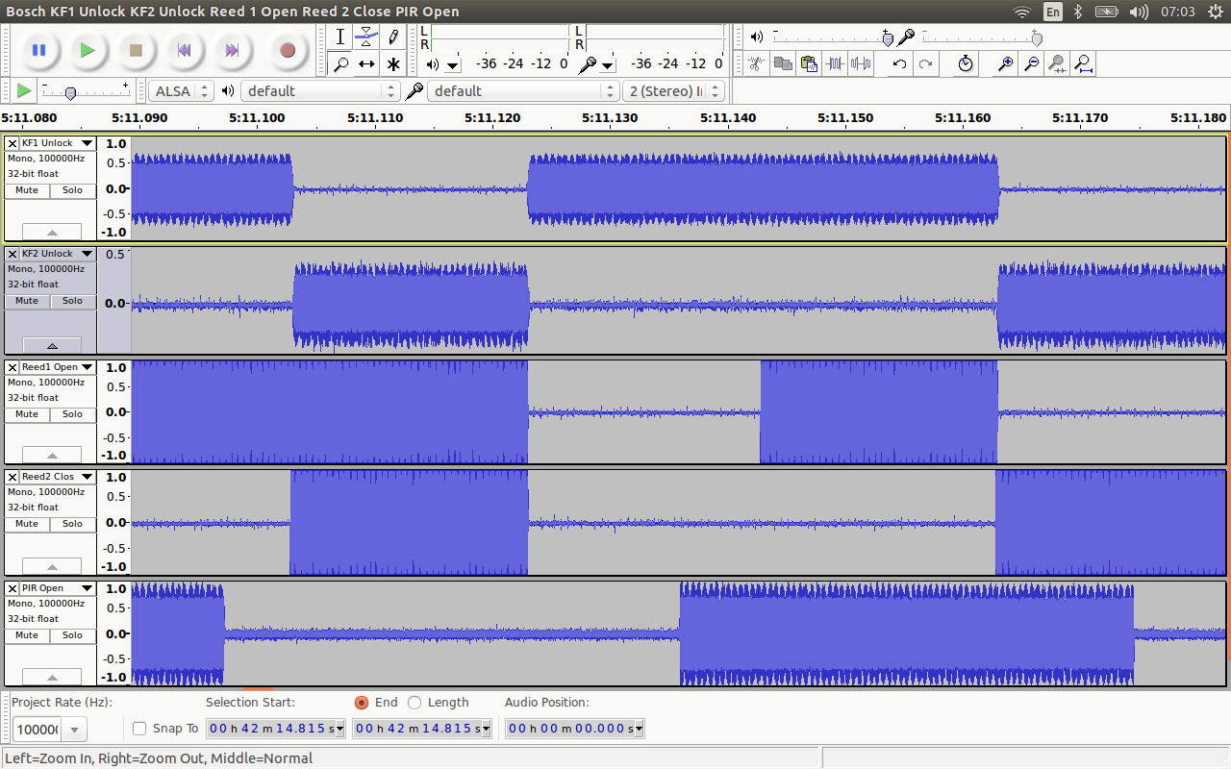

Zoomed in – Level 2 Bosch KeyFob Unlock Symbols
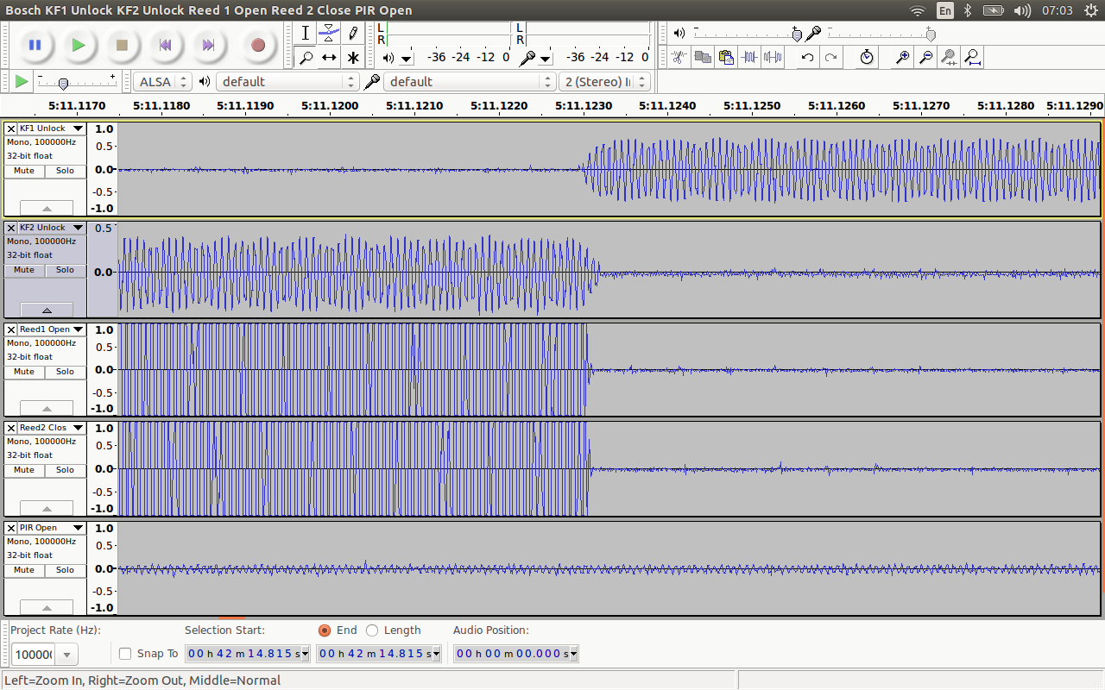

Determine:
1. Preamble pattern you can use as the first identifier. For example: 11001100110011001100110010101011
2. Patterns that identify peripheral and status.
32 bits are the unique peripheral identifier (could be the serial number)
32 bits are the peripheral category identifier (Reed, PIR, Keyfob)
16 bits is the status of the peripheral (Reed open or closed, PIR open, Keyfob buttons pressed)
Rest of signal seems to be the CRC (Reed and PIR), or rolling code + CRC bit (Keyfob)

Add Bosch to the alarm capture code
Remove WX FFT sink from the capture flowgraph used for testing.
Generate the flowgraph top_block file.
Save as and change items (compare to puresignal_4339200000MHZ.py flowgraph):
- Create files:
- puresignal_433420000MHz_external.py
- puresignal_433420000MHz.py
- Add the SELECT FREQUENCY menu item for the new alarm, to the file ./capture_signals.py, and into the while loop.
- If it’s a new frequency (433420000 Hz) then create files:
- runCapture_433420000_external and
- runCapture_433420000_local
- Add killall entries into the stop_run_capture_flowgraphs.sh file.

Add Bosch to the alarm processing code
Once the preamble/Synch word and general patterns have been identified:
- The TestAlarm script process_files _TestAlarm.py used earlier becomes = Alarm Fingerprint tool process_signals.py script. Add the Bosch 3000 alarm option to select, to the process_signals.py selection menus. Add Bosch 3000 to the alarmSET list and add the Bosch 3000 as an option into the select_alarms function.
- Add Bosch 3000 to the process_signals.py process function, into the CPU and waterfall code sections.
- From the signal analysis, decide on the best offset (or offset range). For the Bosch peripherals analysed, using offset 0.05 gave the most detection of the correct signal content. (Note: Some Keyfob signals are missed if an offset of -0.05 is chosen, due to some signals being so low in height they need a -0.01 offset instead. But a small offset like -0.01, can introduce a lot of noise, which then makes it hard for a signal to be properly extracted.) But an offset of -0.21 is better for a Bosch peripheral signal with a height 1.5. You can choose to use -0.01 to -0.21 with step size -0.1, or just use the -0.05 offset, and accept loss of valid signals. Add the chosen offset/offset range, into the run_addconst_flowgraphs script.
- Create the local and external drive gnuradio processing flowgraphs. Bosch3000_FileInput_To_BinarySlice_Local_and_External.py and Bosch3000_FileInput_To_BinarySlice_Local_only.py

Export the top_block from the Bosch_FileInput_Process_to_Binary.grc GnuRadio flowgraph

(Compare exported Bosch flowgraph code to the Yale GNURadio flowgraphs code, the things that need to be added/changed in the Bosch flowgraphs, have been labelled in the Yale flowgraphs – Find # Added and # Change sections in:
Yale_FileInput_To_BinarySlice_Local_and_External.py
Yale_FileInput_To_BinarySlice_Local_only.py

.)

Note: Once the processing code is finished, Test that the newly created Bosch flowgraphs work properly (Process some raw captured Bosch files in single alarm - Bosch mode).
- Write the Bosch signal extract and convert testing code (use the TestAlarm process_bits_Bosch.py script to perfect signal extraction then continue on to step 6).
6. Transfer the preamble detection, and processing test code from process_bits_Bosch.py into alarm_fingerprint.py.
- Transfer convert_bits_to_bosch_data function from process_bits_Bosch.py into alarm_fingerprint.py module as a self contained function.
- Transfer the contents of main section and device_status_bosch function from process_bits_Bosch.py into alarm_fingerprint.py, check_device_type and device_status functions :
Create extract_bosch_packet function ( use this function in the check_device_type and device_status functions. Change print statements to auto_logger.info (logs to console) and also append to output_devicetype list (logs to a log file).
Add the peripheral category (Reed, PIR, Keyfob) detection code into the check_device_type function, in alarm_fingerprint.py.
Add the peripheral status detection (Open, Close, Button pressed) into the alarm_fingerprint.py - device_status function.
- Replace all print statements in the alarm_fingerprint.py, device_status function, with auto.logger.info(status_console), and add what you need to output to the log file into the status list (this is output to a log file at the very end of the processing).
- Add bosch extraction of packet code to alarm_fingerprint.py, extract_packet function.
(Copied and modified the Yale code from its extract_packet function)
6. Add alarmPreambleSynchBosch Preamble detection into the choose_alarm function in process_alarm_hex_auto.py
Add alarmPreambleSynchBosch variable into the open_hex_file function in process_alarm_hex_auto.py
Add alarmPreambleSynchBosch variable into the alarm_transmit_packets function in process_alarm_hex_auto.py
Add Bosch alarmType code into the alarm_transmit_packets function in process_alarm_hex_auto.py
Add Bosch code into the process_mode sections of the delete_nonalarm_files function.

7. Put Bosch test signal captured files (Captured via test flowgraph Bosch3000_Capturesignal.grc) into the AlarmGnuRadioFiles\Captured directory.
8. Run $./process_signals.py and monitor if you are getting the expected results for each of the different modes and alarm systems.

Test that the code is processing your known Bosch alarm signals properly.

Note: Only the Oldest .cap files in the Captured directory are processed and moved.
One (the newest) .cap file is always left in the directory.

Logged debug level and higher to the console. It outputs detected signals, as well as whether signals are present or not, or whether malformed signals are present.
Logged only the Info level to the written log file.

Appendix A – Bosch peripherals (0 and 1 ) frequency count
Return to description text.
Bosch KF1 Dot2_1. Offset -0.05. Full signal height ~0.18
count:0 count:f
103:11 108:11
41:12 42:24
41:24 41:23
40:23 38:12

Bosch KF1 Dot2_2. Offset -0.05.
count:0 count:f
120:11 119:11
59:23 61:23
26:24 26:24
16:12 19:12

Bosch KF1 Dot2_3. Offset -0.05.
count:0 count:f
97:11 101:11
70:24 71:24
35:12 33:12
17:23 18:23

Bosch KF1 Lock1. Offset -0.05. Full signal height ~0.15
count:0 count:f
66:11 83:11
77:24 77:24
58:12 43:12
14:23 16:23

Bosch KF1 Lock2. Offset -0.05.
count:0 count:f
100:11 107:11
71:24 68:11
44:12 39:12
10:23 15:23

Bosch KF1 Lock3. Offset -0.01.
count:0 count:f
78:24 52:24
67:11 67:11
54:12 41:12
5:23 22:23
18:1
5:3
2:1
noisy

Bosch KF1 Unlock1. Offset -0.05.
count:0 count:f
72:11 66:11
56:24 55:24
38:12 46:12
4:23 6:23

Bosch KF1 Unlock2. Offset -0.05.
count:0 count:f
53:11 44:11
13:12 23:12
51:24 51:24
1:23
1:22

Bosch KF1 Unlock3. Offset -0.05. Full signal height ~0.2. only other pattern.
count:0 count:f
188:24
123:51
84:49
79:14
71:26
57:25 58:25
37:50
19:23
15:48
8:54
7:46
5:102
5:47
3:113

Bosch KF2 Dot1_1. Offset -0.05. Full signal height ~0.07
count:0 count:f
42:12 17:12
98:11 125:11
59:24 53:24
24:23 32:23

Bosch KF2 Dot1_2. Offset -0.05.
count:0 count:f
74:11 98:11
50:24 37:24
34:12 12:12
11:23 25:23

Bosch KF2 Dot1_3. Offset -0.05.
count:0 count:f
109:11 114:11
61:24 53:24
22:23 32:23
31:12 28:12

Bosch KF2 Dot2_1. Offset -0.05. Full signal height ~0.12
count:0 count:f
97:11 125:11
71:24 70:24
51:12 25:12
8:23 11:23

Bosch KF2 Dot2_2. Offset -0.05.
count:0 count:f
130:11 97:11
48:24 60:24
14:12 49:12
33:23 23:23
Bosch KF2 Dot2_3. Offset -0.05.
count:0 count:f
122:11 111:11
50:24 62:24
26:12 39:12
29:23 19:23

Bosch KF2 Lock1. Offset -0.05. Full signal height ~0.1
count:0 count:f
123:11 112:11
58:24 48:24
23:23 35:23
21:12 34:12

Bosch KF2 Lock2. Offset -0.05.
count:0 count:f
39:11 27:11
15:24 14:24
1:12 13:12
3:23 5:23

Bosch KF2 Lock3. Offset -0.05.
count:0 count:f
23:11 32:11
13:12 4:12
13:24 12:24
7:23 9:23

Bosch KF2 Unlock1. Offset -0.05. Full signal height ~0.16 (4 parts one pattern, 3 parts other pattern) Could be transmit, then receive patterns.
count:0 count:f
114:11 104:11
50:24 62:24
35:23 25:23
22:12 34:12

Bosch KF2 Unlock2. Offset -0.05.
count:0 count:f
132:11 101:11
45:24 61:24
34:23 20:23
16:12 49:12

Bosch KF2 Unlock3. Offset -0.05.
count:0 count:f
91:11 80:11
37:24 47:24
16:12 28:12
24:23 16:23

Bosch PIR Open1. Offset -0.05. Full signal height ~0.16 down to -0.1.
count:0 count:f
180:11 234:11
128:23 171:23
84:10 29:10
54:22 5:22
10:24
5:12

Bosch PIR Open2. Offset -0.05.
count:0 count:f
149:11 251:11
104:23 149:23
131:10 16:10
70:22 3:22
26:24
17:12

Bosch PIR Open3. Offset -0.05.
count:0 count:f
172:11 259:11
158:23
108:10 22:10
105:23
69:22 4:22
16:24
3:12

Bosch Reed 1 Close1. Offset -0.05. Full signal height ~0.16
count:0 count:f
226:11 96:11
180:12
70:24 151:24
100:23 1:23
46:10
22:25

Bosch Reed1_Close2. Offset -0.05.
count:0 count:f
212:11 112:11
88:24 165:24
164:12
82:23
60:10
9:25

Bosch Reed1_Close3. Offset -0.05.
count:0 count:f
109:23 1:23
99:11 227:11
181:12
56:24 151:24
50:10
17:25
1:8

Bosch Reed1 Open1. Offset -0.05. Full signal height ~0.18.
Both patterns.
count:0 count:f
4:152
4:151
6:103
2:102
1:83
1:77
3:74
1:70
25:26
55:25 86:25
240:24 213:24
137:23 2:23
212:11 100:11
162:12
1:13
1:14
1:18
6:53
3:51 101:51
5:50 78:50

47:49 1:49
8:48
4:47
1:37
1:36
1:34
47:10
2:8
2:7
1:5
2:4
3:2

Bosch Reed1_Open2. Offset -0.05.
count:0 count:f
236:11 96:11
180:12
57:24 147:24
113:23 2:23
36:10
25:25

Bosch Reed1_Open3. Offset -0.05.
count:0 count:f
253:11 82:11
210:12
67:24 154:24
95:23
35:10
25:12

Bosch Reed 2 Close1. Offset -0.05. Full signal height ~0.16
count:0 count:f
242:11 78:11
206:12
128:23
38:24 128:24
42:25
38:10

Bosch Reed2_Close2. Offset -0.05.
count:0 count:f
154:11 68:11
128:12
36:24 86:24
59:23
39:10
11:25

Bosch Reed2_Close3. Offset -0.05.
count:0 count:f
242:11 92:11
216:12
54:24 135:24
100:23
62:10
23:25

Bosch Reed2 Open1. Offset -0.05. Full signal height ~0.18
count:0 count:f
216:11 113:11
155:12
142:23
32:24 124:24
54:25
48:10

Bosch Reed2_Open2. Offset -0.05.
count:0 count:f
129:23 1:23
189:11 86:11
144:12
37:24 132:24
38:10
38:25

Bosch Reed2_Open3. Offset -0.05.
count:0 count:f
37:10 1:10
147:11 66:11
121:12
56:24 107:24
60:23
11:25

Find the common hex patterns for each Bosch peripheral preamble.
03 fx24 c0
1f fx22 fe
7f fx22 f8
fx24 f0
01 fx24 e0
3f fx22 fc

01 22f
03 22f
07 22f
0f 22f
1f 22f
3f 22f
7f 22f
ff 22f

